EXPERIMENT NO: 7

Name: Mukhilan. S
Reg No: 192512196
Subject: Analog and Digital Communications
Code: ECA-0803

Program:
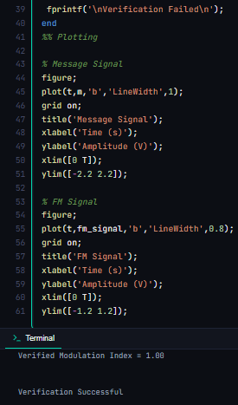
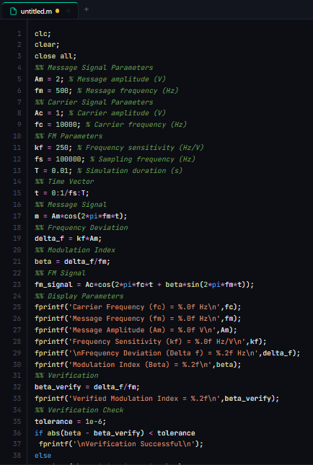

Output:

